1. Provide a screenshot to show that the Java Docker *container* named javamaven has been created on port 8080.



1. Provide a screenshot to show that the javamaven *container* CLI has been updated.

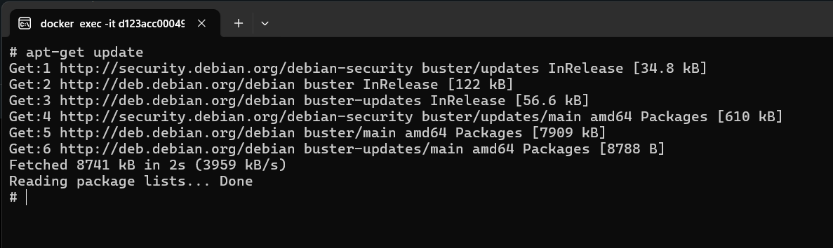

1. Provide a screenshot to show the Spring Initializr webpage with the correct settings selected.

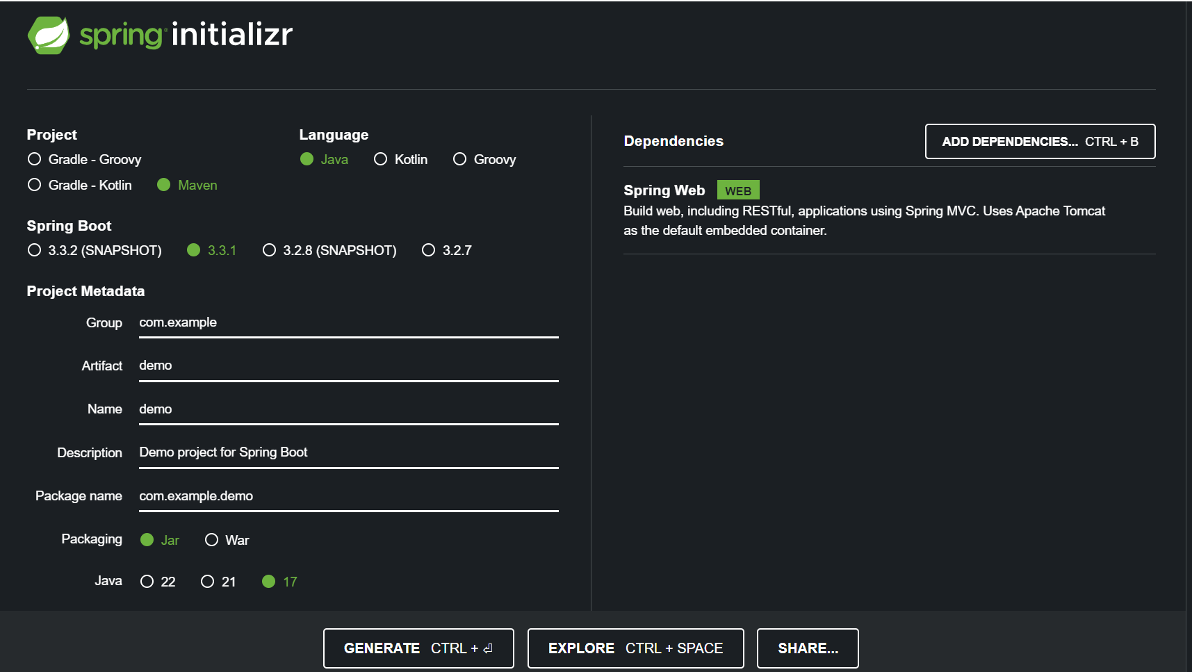

1. Provide a screenshot of the unzipped demo.zip folder.

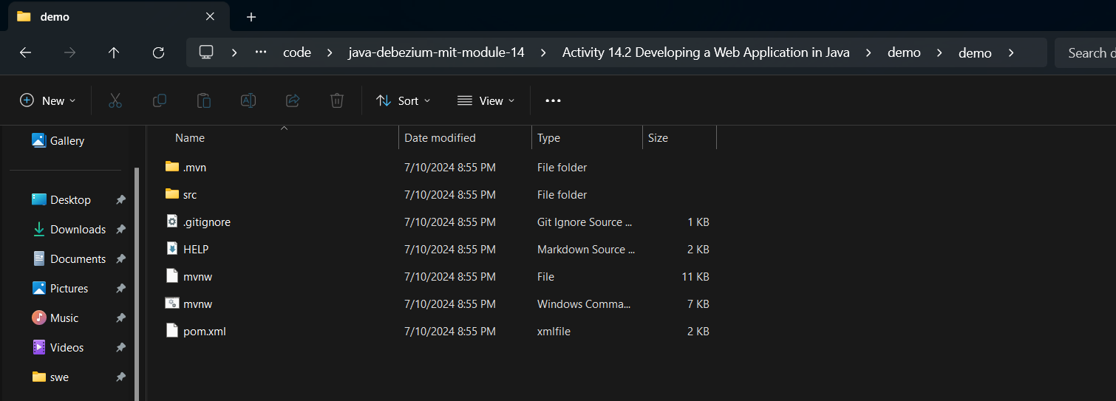

1. Provide a screenshot of the folder that shows the upload files.



1. Provide a screenshot to show that you ran the docker cp command to upload files into the javamaven *container* home folder.



1. Provide a screenshot to show that the files from your local machine demo folder successfully uploaded to the javamaven *container*.

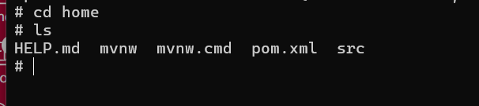

1. Provide a screenshot to show the DemoApplication.java file.

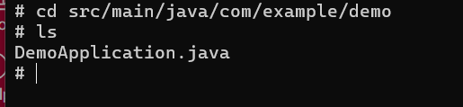

1. Provide a screenshot to show that the code in the DemoApplication.java file was updated successfully.

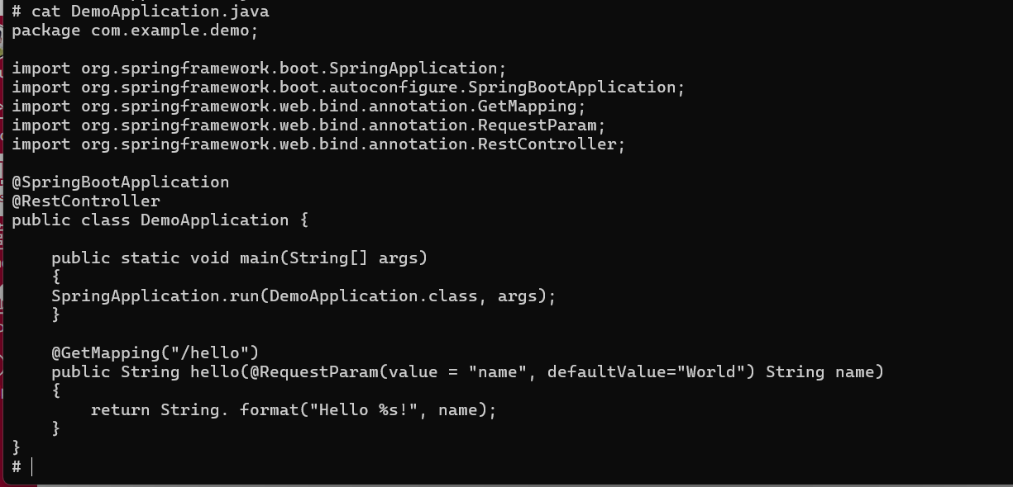

1. Provide a screenshot to show that the Java web application that you have created is running.

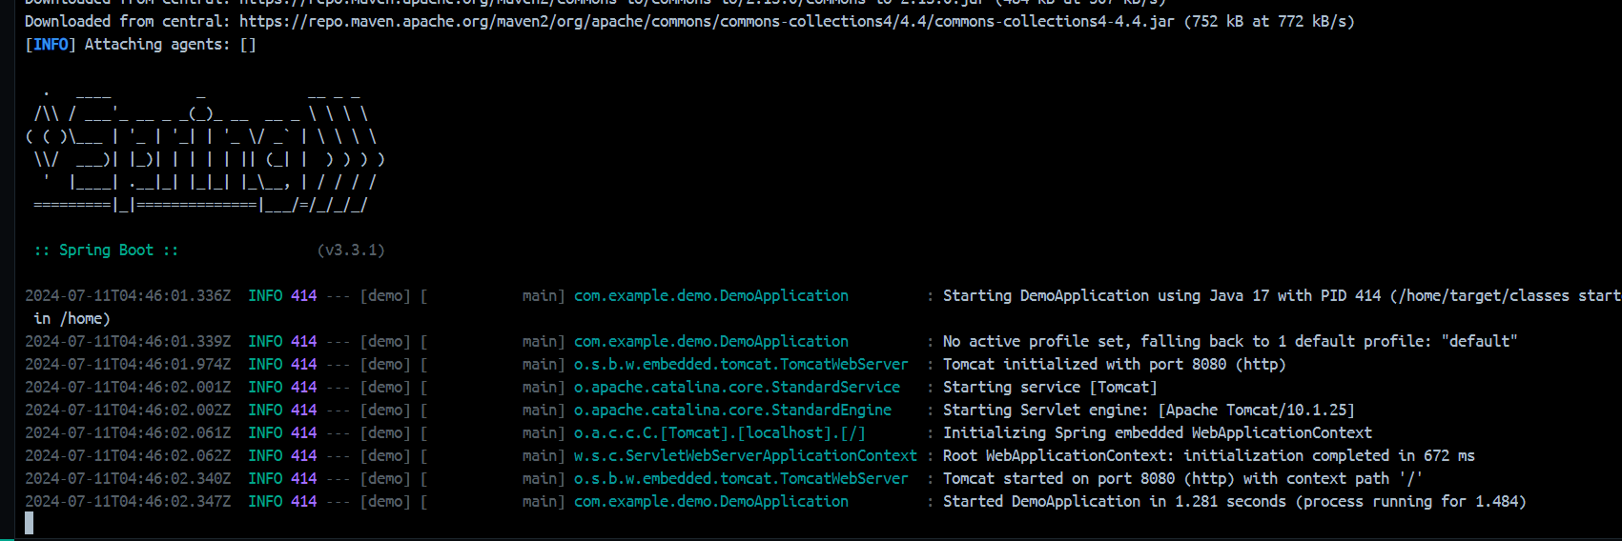

1. Provide two screenshots. One screenshot should show that you were successfully able to navigate to localhost:8080/hello. The second screenshot should show that you were successfully able to navigate to localhost:8080/hello?name=John.

